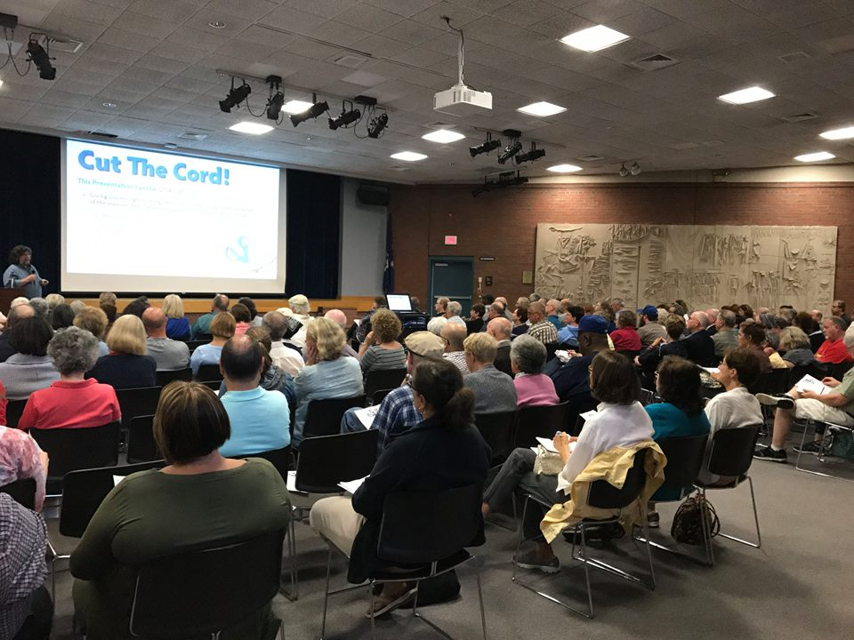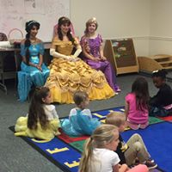

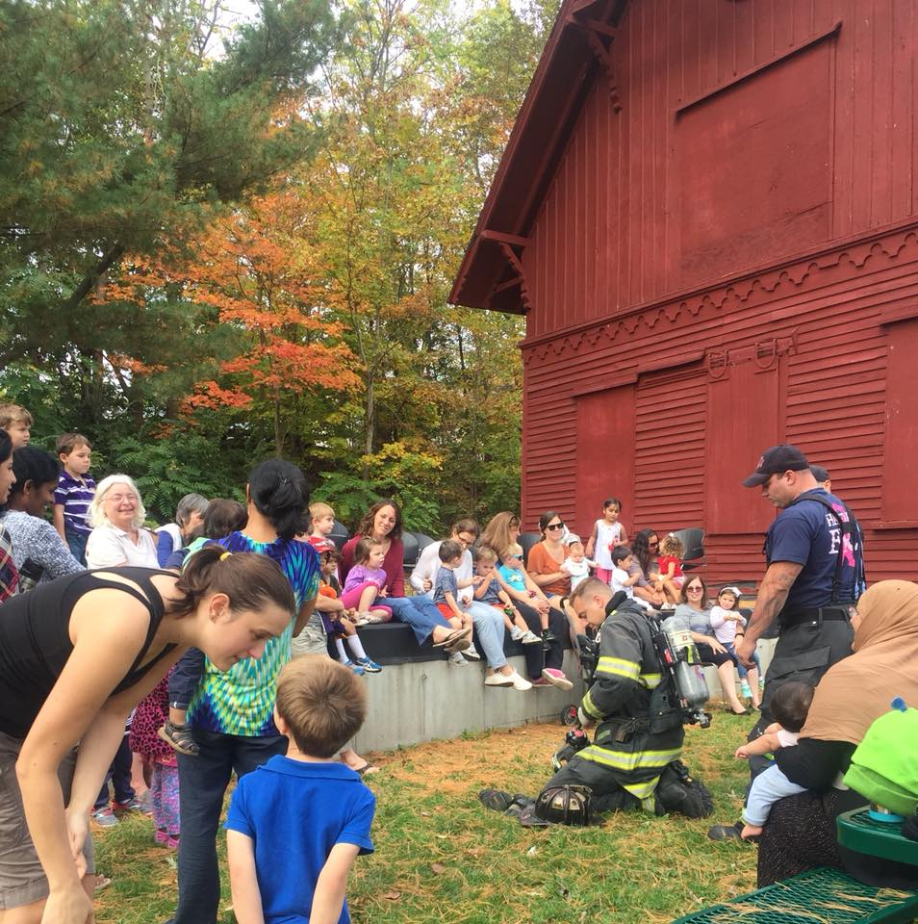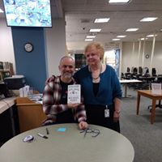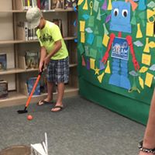

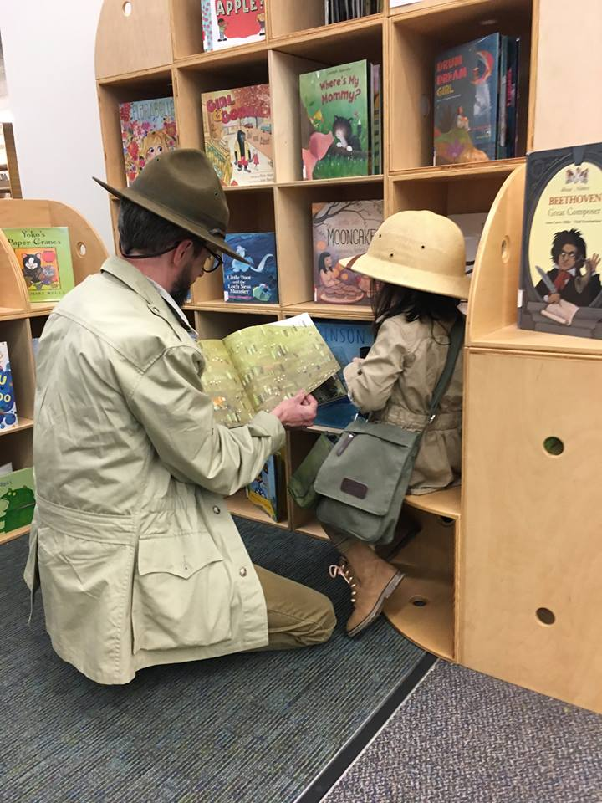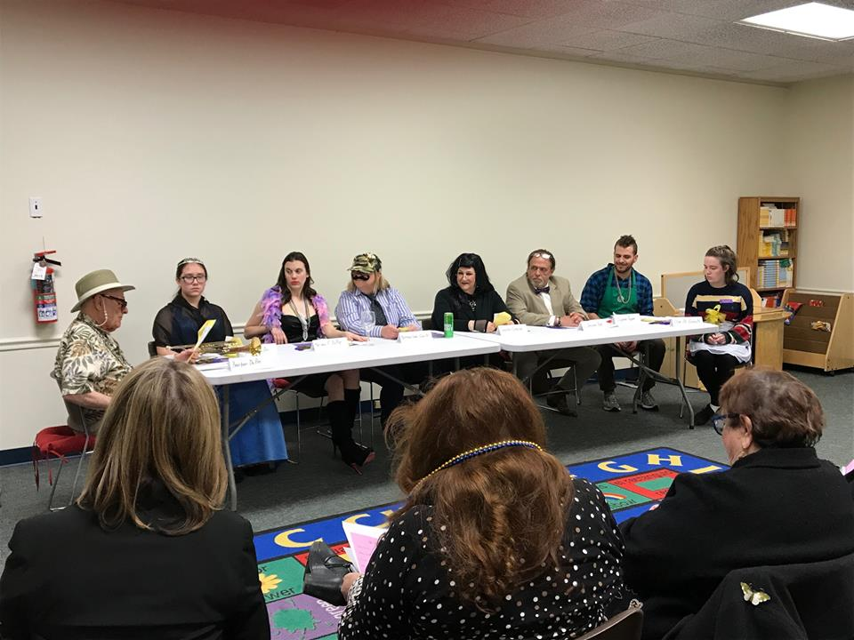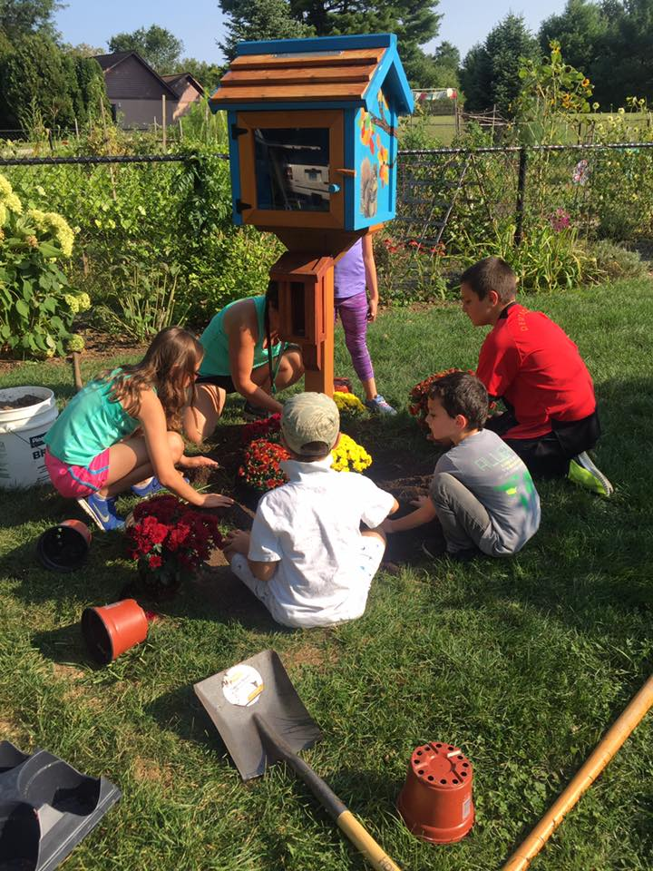

Annual Report 2017-18
Marian Amodeo, Director
Contents
Introduction 1
People 2
Program Highlights 3
Plusses 5
Professional Participation 7
Planning 8
Problems 9

Hamden Public Library Annual Report 2017-18

Introduction
The Hamden Public Library is proud to present its annual report for Fiscal Year 17/18 (July 1, 2017-June 30, 2018). It was a busy, exciting, and challenging year, one in which the staff provided excellent customer service to Hamden residents. The library inspired creative thinking, offered access to materials and online services like never before, encouraged economic success, and continued to build partnerships.

people
Big changes were in store for the Children’s Department as former Librarian I Marcy Goldman was promoted to Head of Children’s Services. Teen Librarian Alyssa Bussard, who had been operating from Adult Services, was moved into this department. And, PT Clerk Johnea Lomax moved into the department as well.

We said goodbye to long-time staffer Annalynn Russo upon her retirement from the Borrower Services Department. An internal promotion to her LTA position was filled by veteran library clerk Jan Hebel. Other internal promotions then occurred, as two PT Library Pages moved in to FT Clerk positions- Pam DellaRocca and Lisa McCarthy.

Also, former Clerk TJ Rooney completed his MLS program just in time to be promoted to Librarian I in the Information Department. PT Librarian Lisa Murno moved on to a FT positon at another library. Joanna Pfaff was hired and was assigned to work at both Miller Library and Whitneyville Branch. Library Pages Ryan Keeler and Dominic Carini were also new additions to the staff.

Negotiations with Local 1303-115 of the AFSCME library bargaining unit continued for some time. A new six-year contract was signed.

The Library Board welcomed new member Philip Kuchuk at their December meeting.

program highlighTs

Programs for adults increased in quantity and most assuredly in quality, as over 800 people attended events on such timely topics as reducing cable services, hiking the Appalachian Trail, and Mindfulness and Meditation. A Mardi Gras Murder Mystery was performed as part of the Adult Winter Reading Program as well.

The public library’s collaboration with Hamden schools became even stronger during the year. As part of the curriculum, every kindergarten class now visits HPL for an orientation, a story-based program, and the distribution of library cards. A plan is now in place for all 4th grades to also visit during next school year.

And, for the first time, Hamden Middle School, as well as all eight elementary schools were visited by Children’s Department and branch staff in June in order to promote the myriad activities that were available at the library during the summer months. Partly as a result of these visits, we recorded the highest student participation in the summer reading program in recent years- 826 elementary and middle school students at all three library sites!

Another new and important collaboration with Hamden schools began when Children’s Department staff and the Hamden schools’ World Language department hosted a night at the library for ESL families. The event brought in over 125 people, who were treated to dinner, presentations for parents, and a scavenger hunt for children. Families from countries all over the world received an introduction to the library and its services. We are making plans for this to become a bi-annual event.

The annual Take Your Child to the Library Day brought in over 200 visitors to the Miller Library. Books and other gifts were distributed, and families enjoyed free crafts throughout the day. Balloon artists were on hand for several hours, thrilling children with their creative designs. At the Whitneyville Branch, local--and nationally-acclaimed--children’s book author and illustrator Deborah Freedman read to children and led them in an art project.

The teen program schedule was ramped up this past year in order to attract more of this age group to the library. It certainly did, as 48 programs were held for almost 550 teens. The teen summer reading program, Build a Better World, counted over 100 participants- and it’s only the second year such a program was offered.

A joint program from Children’s and Teen Services was a hit with 74 participants. Potterpalooza featured several stations that “sorted” children into their Hogwarts houses, helped them to make wands, get a temporary tattoo, take a picture in the “photo booth,” or attend a potions class where they could make slime. The wizard rock band Draco and the Malfoys was on hand to share Harry Potter related songs and do trivia with the group.

The library’s reach to Hamden’s business community was greater, as 7 business programs attracted a total of 111 people. Miller Library continued to be a satellite sight for the SCORE Mentoring Project. Business professionals continued to ask for and receive AtoZ Database demonstrations.

The Whitneyville Branch continued low-to-no-cost programming endeavors, taking chances on ideas like the Explore Playgroup, and Crash Lab from the Science Center. The branch hosted 2837 attendees--compared to last year’s 2179--at 133 programs (last year we held 83 programs). This represents a 60% increase in programs offered, and a 30% increase in attendance.

The 2017 summer reading program at the Brundage Community Branch was a success. 60 children participated throughout the summer. Overall, program attendance increased slightly from last year: 1789 up from 1731 the year before.

plusses

The Friends’ Board met on a quarterly basis in order to discuss new business, receive a status report on the bookstore, and accept requests from the library for funding. During the last fiscal year, the Friends funded over $10,000 for library programs at the three locations, as well as the entire museum and attraction pass service.

And, it was time for celebration at the Annual Chamber Choice Awards night as the Friends of the Hamden Library received the Community Advocate Award for 2017…deservedly so.

The Technical Services Department underwent a much-needed and long overdue renovation. Tucked away and stuffed into a back room that was not designed to accommodate the necessary workspace, storage, and staff that the department required, it also hadn’t been designed with computer accommodation! Finally the staff was able to design the space to suit their needs, and a great contractor was hired to help make the vision a reality.

The LION consortium, of which Hamden Public Library is a member, invested in a new discovery layer, PIKA, for the online catalog. The catalog now has all formats of a title on a single record, so it is easy to see what versions are available at the library. PIKA also enables each of the LION libraries to customize their own catalogs interfaces, so the catalog is visually integrated with the individual library’s web site.

Head of Technical Services Jessica Dans created a new library website that has a much brighter and cleaner look. It also works better on mobile devices, which is important since nearly 40% of our web traffic comes from smart phones and tablets.

After the demise of the CT State Library’s delivery service, the LION consortium took the lead and contracted with a private vendor, resulting in a 4-day-a-week delivery service for all LION libraries. The effectiveness of this service is beyond measure, as Hamden patrons are finally receiving excellent delivery service. Materials among the 30 LION libraries are shared equally, so that library patrons get their desired materials in one or two days, a far cry from the one- two week wait of the past.

HPL’s virtual library presence and digital outreach was expanded during the year. The library’s blog, Pinterest and Facebook sites grew, and a Library Instagram account was established. The library now counts over 1,500 Facebook followers and over 2,000 Constant Contact subscribers. People are becoming acclimated to the process of online program registration which is helpful in both planning programs and communicating with attendees. And, another new service was rolled out- Shoutbomb- a text messaging service that is available through LION.

The Brundage Community Branch experienced very high public computer use. The number of public computer sessions was 5240, up from 3928 the previous year- an increase of nearly 34 percent.

Miller Library saw a healthy 10% increase in reference and informational questions this past year- 16,884 questions, an average about 1407 per month, as compared to the previous year’s number of 15,091 or 1258 per month.

A proposal was submitted to the Library Board for a Mobile Computer Lab, consisting of a laptop charging cart, 12 Google Chromebooks and two iPads. With their very generous support, all equipment was purchased, and the library began to offer an ambitious series of hands-on computer classes that have proven to be wildly successful.

A roving reference service was instituted for the purpose of offering staff assistance beyond the scope of the reference desk, at the point of need on the four levels of the library.

Working in collaboration with Elizabeth Lapman, Director of English Language Learning / World Languages, we instituted an initial World Language collection consisting of Spanish, Korean, Arabic and Mandarin titles.

The second annual Whitneyville Civic Association fundraiser brought in $2,325 for our gift fund. Funding from the first event was used to purchase new toys for the playroom, a starter collection of adult graphic novels, many children’s books, and multiple Oscar-nominated and -winning DVDs. It also funded two multi-week children’s programs that were very well-received.

professional participation

Annual awards have been established for creative ideas and implementation among library staff. Winners of last year’s Innovation Awards were: Alyssa Bussard for her Warm Up America Knitting Program, Michael Pierry for the mobile computer lab, Nancy McNicol for the New Fiction area makeover and Janet Perrotti won the library-wide prize for her handling of the delivery service changeover.

Staff Development Day was held on August 30th. It was a day of sharing, as all staff took to the road during the summer and visited libraries throughout the state. Staff reports were amazing, offering everything from PowerPoint presentations, to photos, oral reports, and statistical analysis. We all learned so much about how other libraries do business, garnered ideas that we might be able to adapt to our situation, and were able to compare HPL to others, with a focus on all that we do right! Also, staffers Michael Pierry and TJ Rooney presented a workshop for all staff on the staff WIKI. A mindfulness program given by Mike McCabe rounded out the day.

Library Director Marian Amodeo completed her 18 month stint as president of the LION consortium. During that time, she spearheaded the recruitment of a new executive director, convened a task force to investigate supplemental delivery service for LION libraries, resulting a new and reliable service, and began a strategic planning process.

Outreach and staff training were constant endeavors. HPL staff was everywhere- from HPYC to Hamden Chamber of Commerce events, from Earth Day to the Keefe Center to neighborhood civic associations, and school open houses. They were present at the business expo, senior health fair, and Healthy Kids Day, to name a few. HPL was represented at library roundtables around the state, in-house webinars, customer service workshops, security workshops, and active on LION committees.

planning

Evaluation and planning sessions were held with library managers and library administrators. Managers had completed meetings with their respective staff for the same purpose. Goals for the new fiscal year were set and recorded as the Plan of Work for 2018-19.

Plans for a dedicated space for teen patrons is progressing. New furniture, more computers, and other amenities for this age group will be completed in the new year, as well as increased programming and staffing.

Ideas are being discussed regarding next steps for technological enhancements at the library. Charging stations for patrons’ mobile devices are needed, as well as more devices with which to teach more computer classes.

Plans are in place for the replacement of ceiling tiles during summer 2018. And discussions continue around plans to reconfigure the former reference area, turning it into more meeting/innovation space.

More business programs are anticipated, as staff work with the town’s economic development officer on shared efforts. Library staff launched a small business survey on various platforms and received the total allotted 100 responses to it. Much information was gathered as to peoples’ needs and time preferences.

For the Friends, plans for additional hours for the Friends’ book store are being discussed. Also, a large scale booksale to be held in 2019 is a goal that all are working toward.

Now that the library has reached some year-to-year goals, the Library Board will begin to develop a more strategic mapping in order to direct a vision for the library’s future. They will work with consultants and the CT State Library to help steer the process.

problems

We sustained a $30,000 dollar budget cut in February, which was a major blow to our collection development in the second half of the year. We had to eliminate the Lucky Day collection, which had been very popular with our patrons. Staff will have to use money from the next fiscal year to purchase titles they couldn’t get in the spring.
Physical plant problems with both branch libraries continue unabated. We continue to be frustrated by the lack of movement in implementing repairs and improvements to both buildings. The basement rooms, which are used for programming and neighborhood gatherings, need complete overhauls. Also, lack of heat, severe leaks in ceilings, windows and walls, loss of books due to water damage, electrical outages…the list goes on.

