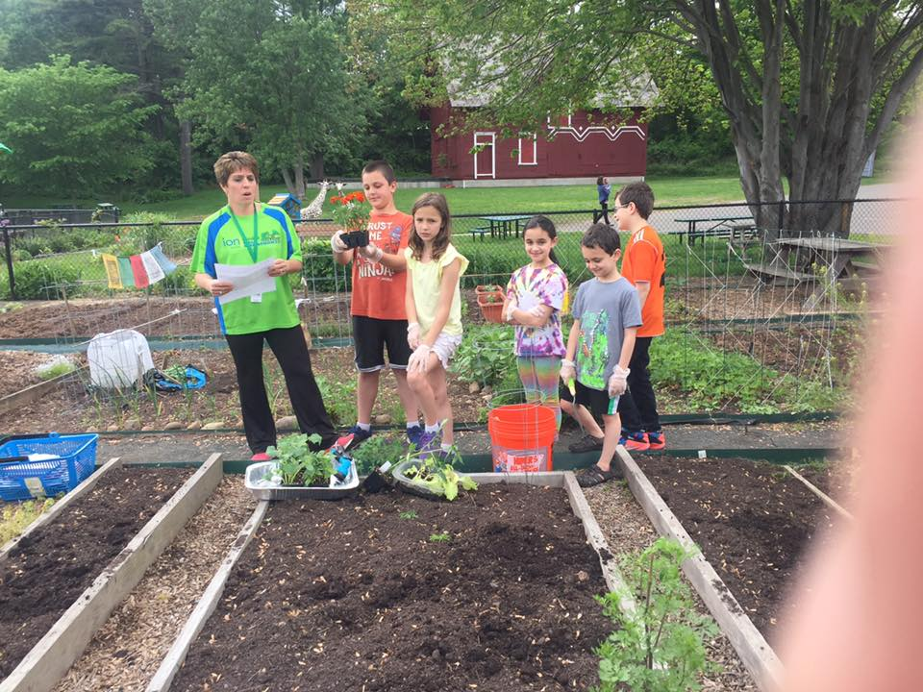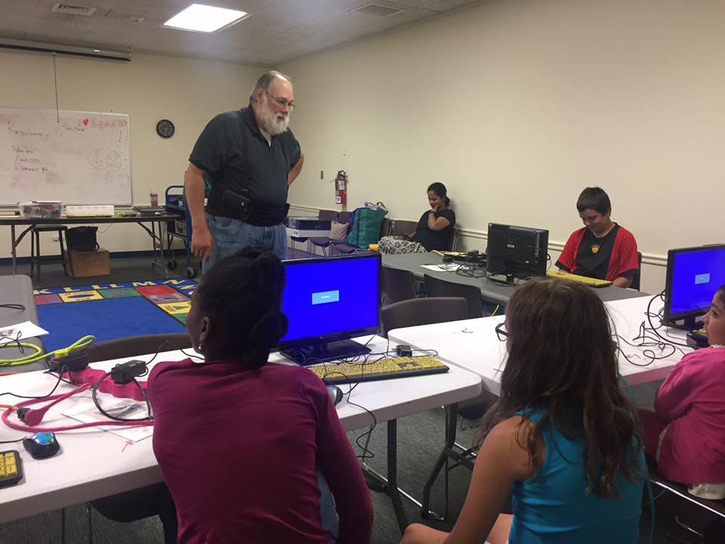
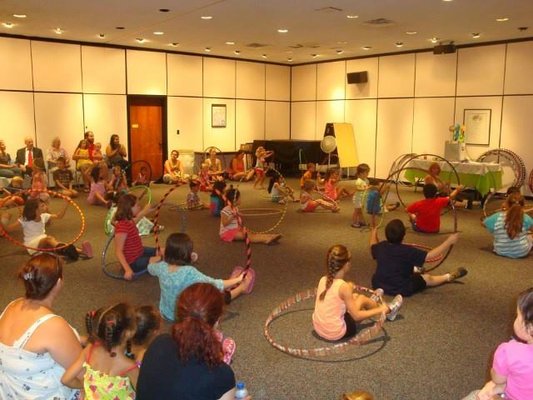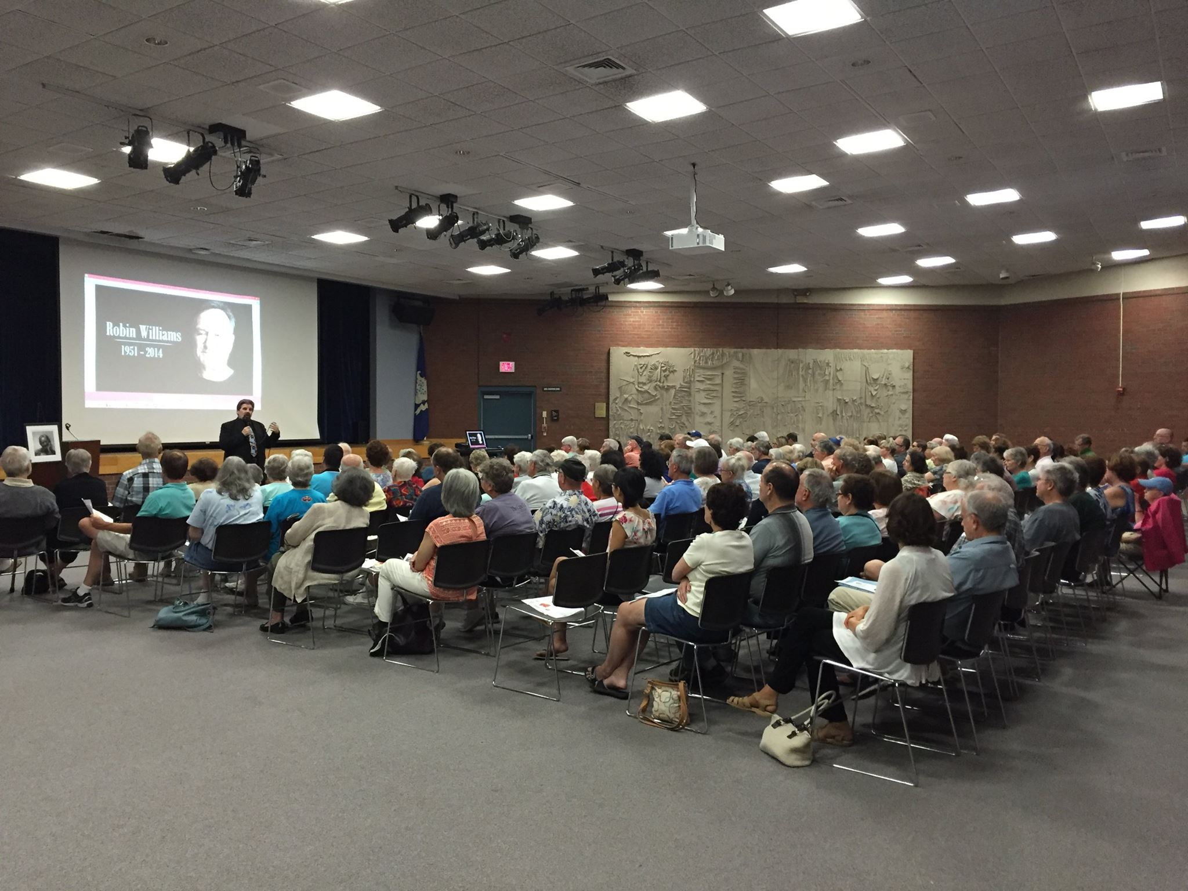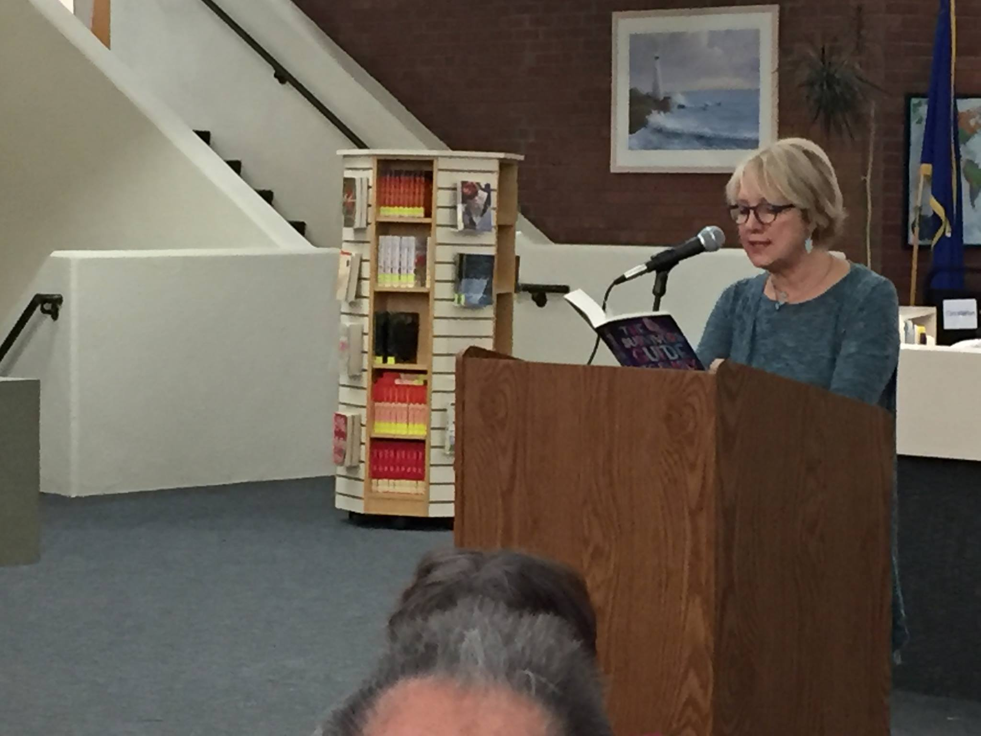
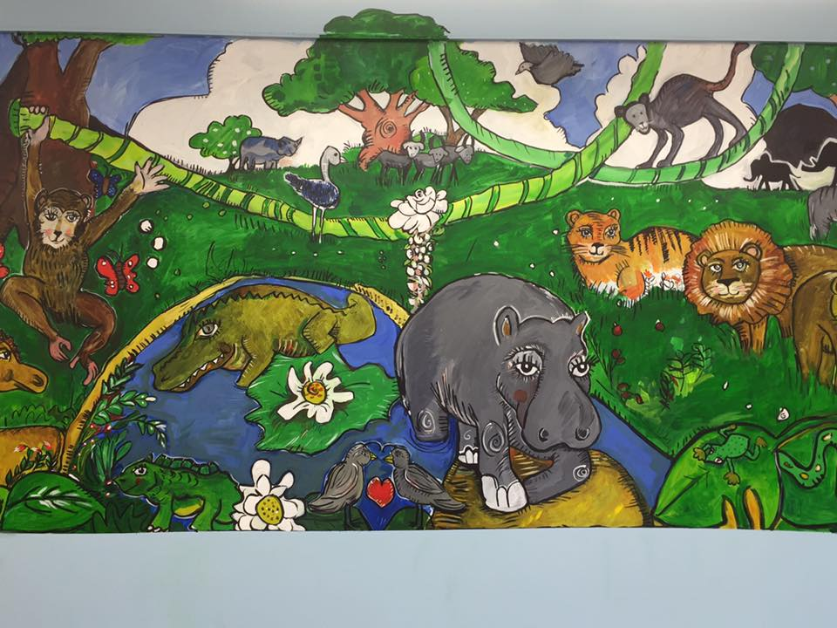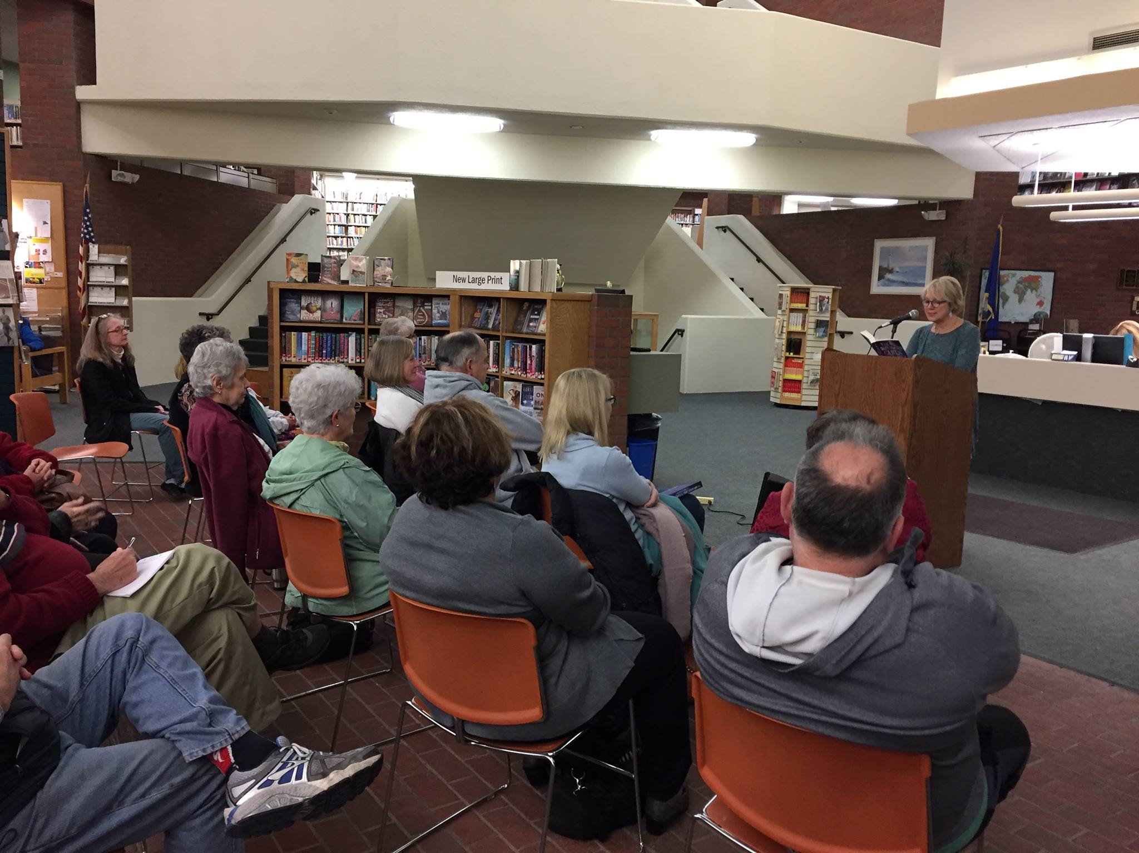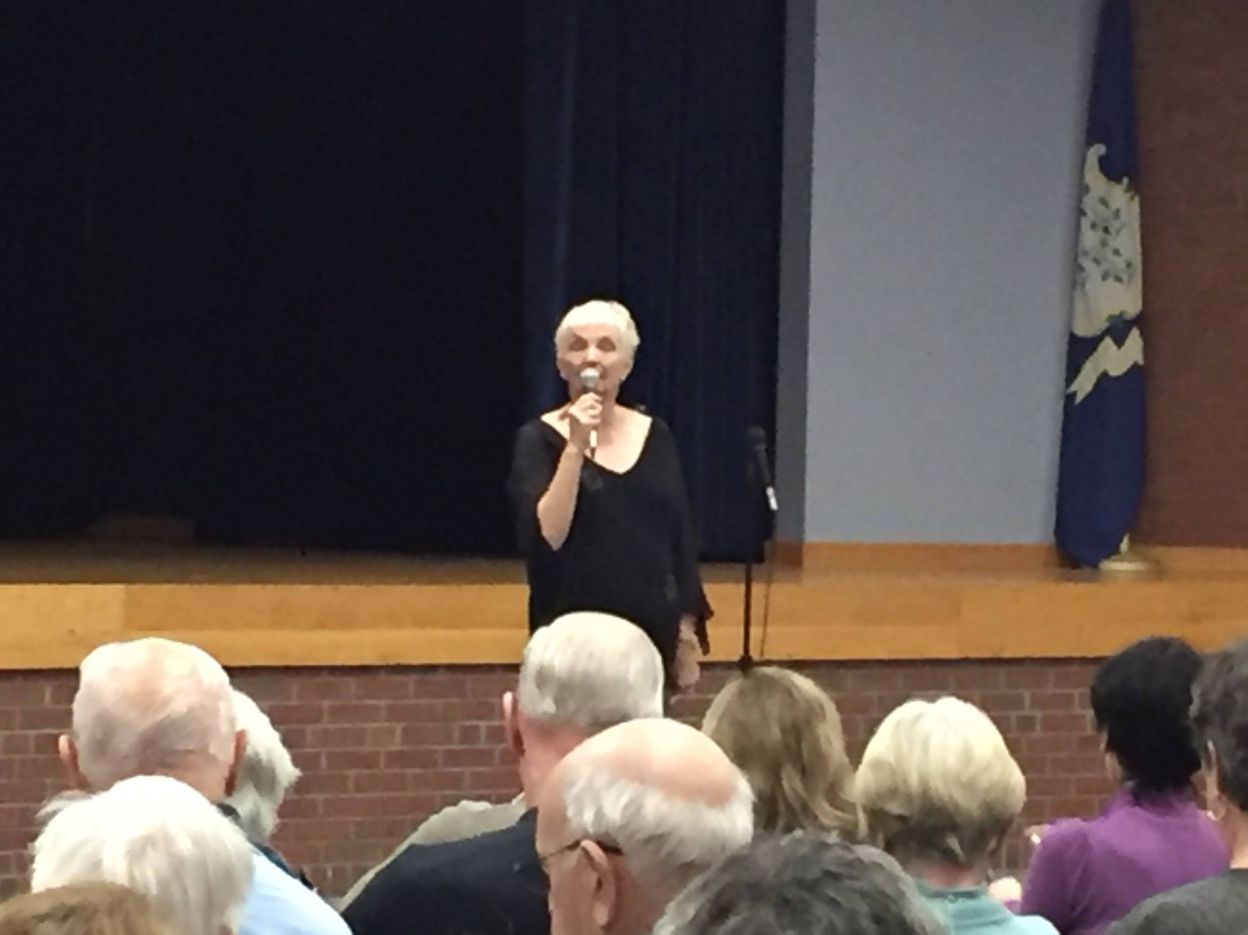
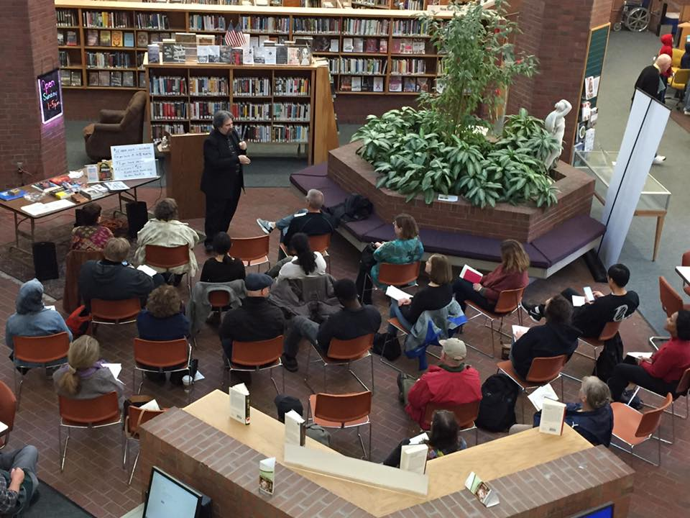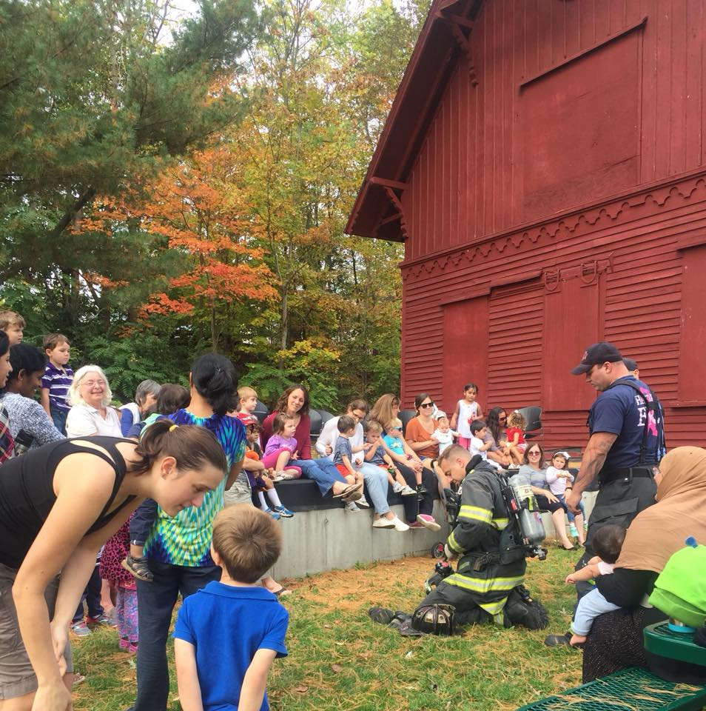

Annual Report 2016-17
Marian Amodeo, Director
Contents
Administration Error! Bookmark not defined.
People Error! Bookmark not defined.
Program Highlights 2
Plusses 3
Professional Participation 4
Planning 5
Problems 5

Hamden Public Library Annual Report 2016-17

administration
The new fiscal year began with a nearly $30,000 cut to the materials budget. We had to make cuts to nearly every collection line. We cut a number of expensive databases that we not heavily used to offset the deficit. Even so, the cuts that are necessary in the purchasing of materials creates gaps in the collection that negatively affect the experience of Hamden library users.

In December, Alexandra Roman filled a vacancy on the Hamden Public Library Board created by the retirement of Evelyn Hatkin earlier in the year. Ms. Roman became the fifth member of this small but dedicated Board. Also in December the board held a reception in order to thank the library’s financial supporters, discuss progress and advocacy, and, hopefully, attract more donors. Hor’doevres, punch, and good conversation were enjoyed by the 50 attendees.

Marian took on the LION presidency responsibilities in January 2017. This 18-month commitment includes running board and committee meetings for a consortium of 29 libraries and helping to shape the future of the group. This past year, we succeeded in recruiting a new executive director, and put a delivery service in place in order to move library materials among the LION libraries.

New signage was installed in various areas on the main level of the library. Information, Patron Services, Children’s, Early Learners, Copy Center, Business and Career Center, and restroom signs all bear the library’s signature logo in a clean design. Other building projects included the creation of original artwork throughout the Early Learning Center as well as a new service desk in that room, landscaping on the Dixwell Ave. side of building, and computer and furniture replacement.

A large event of note that we were able to arrange in the spring was a visit by popular children’s author Brandon Mull who came to us courtesy of his publisher and the North Haven Barnes & Noble. We were able to arrange for all 4th graders in Hamden to be bussed to Thornton Wilder Hall giving three hundred children to enjoy Mr. Mull’s presentation, mingle with the engaging author, and have books autographed by him. We hope to be able to arrange more of these events, as they provide a win-win for all- library, schools, students, bookstore, and author!

The library was closed to the public for one morning in June to give the full staff an opportunity to recognize and celebrate the strategic goals that were achieved during the preceding year. Along with a critical evaluation of the year’s accomplishments and planning for the months ahead, the meeting generated a discussion of opportunities for staff to visit other Connecticut libraries during the summer months. A staff development day was scheduled for August to continue the planning process and report on the discoveries made during the various library visits.
This year, for the first time ever, the Children’s Department and branch staff visited all eight elementary schools in Hamden to promote the summer reading program, STEAM Into Reading 2017. This was the beginning of what we hope will be an annual collaboration with the schools to promote reading and the library during the summer months.

people
The Hamden Library welcomed new staff, happily promoted staff, and bid goodbye to staff. Part-time positions were filled by new staff members Betsy Goldberg, Lisa Murno, Elizabeth Koskoff, and Sandra Hughey. Promotions included Pam DellaRocca from page to part-time Library Clerk in the Children’s Department, Paula Ginter from page to full-time Library Technical Assistant in the Children’s Department and Alyssa Bussard to full-time Librarian I in the Information Department. Several people also came on board as new Library Pages. 2017 also saw the retirement of Head of Children’s Services Nancy McLaughlin. Sadly, long-time part-time cataloguer Robert Killheffer passed away leaving a vacancy in the Technical Services Department.

program highlights
What an amazing array of programs were offered by the library during the year. There were so many highlights it is difficult to choose, but below are some of the newer and/or more popular programs/services that Hamden residents enjoyed.

Sixteen business programs were offered, ranging from an A-Z Database Demonstration to Marketing your Business in the Digital Age. Also this year the library became a satellite site for SCORE, an organization of retired executives which provides free advice to small businesses. This new alliance provided many one-on-one sessions of mentoring for our business community.

Julie Harris and Stephen Roane’s An Evening with Cole Porter, Artscapade’s presentation on Matisse and Picasso, and an offering by historian Matthew Bartlett on Civil War Tales of the Supernatural were highlights of adult program efforts. A Mindfulness workshop presented by Hamden resident Michael McCabe attracted a full house.

At the Whitneyville Branch Mindfulness for Kids, Reflexology for Kids and Their Grownups, Meet a Detective!, Winter Wonderland, Crochet Away the Cold, and Mother Goose on the Loose filled the room, and Summer Reading highlights included Claydate, Critter Caravan, and a well-attended evening program called The Game, a free offering from Arts for Learning that emphasized creativity, teamwork, and engineering skills.
At the Brundage Community Branch Trash to Tunes during which musician Dennis Wearing demonstrated how to construct musical instruments from discarded household items brought in over 60 people. This event was held in the evening and pizza was served after the program. Other activities at this branch included Rock on With Mr. Gym and the ever popular Music and Movement with Lynn Lewis.

Hula Hoops, gingerbread houses, healthy eating for children, and a Pancake Supper Storytime were but a few of the many programs held for children at the Miller Library. In February, we hosted close to 300 families who visited for Take Your Child to the Library Day. Free tote bags courtesy of the Friends of the Hamden Library were distributed and several child-friendly activities were enjoyed throughout the day.

In June 2017 the Children’s Department secured a plot in the community garden. Children were given an opportunity to tend the garden weekly. This activity was accompanied by a discussion of their progress and capped off by reading a book about gardening together. This was scheduled to continue throughout the summer months and into harvest time.

120 teens participated in our excellent, first-ever teen summer reading program. In addition to vying for prizes, they attended such programs as a game night, an ice cream social, a trivia night, and Chocolate Olympics! Other programs offered by the library during the year to pique the interest of teens included Sharpie Tie-Dye, Cupcake Wars, and a pizza taste-off. A Teen Advisory Board (TAB) has been formed which meets with library staff to help plan and implement such events.

plusses
This year we instituted an annual award for best innovation by library staff members. Each department chose the person (or persons) who had contributed the best new idea for that department during the course of the year. Winners were awarded a gift card and their name was engraved on a plaque that hangs outside the staff room—hopefully, as an inspiration for further innovative thinking.

The Whitneyville Civic Association actively advocated for their branch with the Town, presenting their own analysis of needed improvements to town officials. They sponsored a fundraiser at The Playwright with almost 100 in attendance, raising well over $2,000 for library materials and other needed items. Arbor Day festivities sponsored by the WCA included not only a neighborhood clean-up but the planting of several trees on the branch’s grounds.

A staff wiki was created to provide a readily accessible guide to in-house procedures and best practices. It has been particularly helpful for new staff, staff working outside their usual departments, or when dealing with infrequently occurring issues. Peer training continues as more staff use this important tool.
We encouraged creative writing among high school students with the Thornton Wilder Writing Competition. High school students from New Haven County sent in 147 entries. The reception for the winners was held in the rotunda of the library. This has become an important collaborative project, as the library, the Arts Commission, and the Hamden resident judges all work together to make it the success that it is.

The popular Book-A-Librarian sessions were introduced during the year. More than 60 of these one-on-one PC sessions were taught by library staff at Miller Library. Both branches followed suit and patrons at those locations also fill up the available time slots for this much-needed service.

Each year the small but dedicated group of Friends of the Hamden Library works diligently to raise funds to sponsor many of the library’s programs and special events. Proceeds from the Second Hand Prose Bookstore and membership dues is generously donated to the library for the summer and winter reading programs, the museum and attraction pass program, and many other specials. This year, a sampling of bookstore offerings has been made available on the main level of the library, which is re-stocked each day by a single, dedicated volunteer. Patrons love to buy “impulse” items on their way out the door.

Pathfinders are a tool designed to help patrons to more easily locate resources on such often-requested topics as College Resources, Computer Basics, English as a Second Language, Genealogy, High School Research Topics, Legal Information, and Personal Finance. Staff researched these topics and then prepared attractive brochures enumerating the best sources of information for each subject.
Demand for the print version of our newsletter continues to grow so that we now have 1,500 copies printed quarterly while our email subscription list currently stands at over 1,800. We continue to make use of Constant Contact, Facebook and the library website as marketing tools, as well as press releases for local news outlets, plus fliers, posters and brochures in print format.

professional participation

Library administrators recognize the importance of continuing education and are committed to encouraging staff to attend the many options for professional development within the state. Staff participated in a myriad of classes, workshops, webinars, and conferences dealing with such topics as Programming, Dealing with Difficult Patrons, Design Principles for Great Flyers, and roundtables on graphic novels and young adult services. Webinars included Power Searching, JobNow Database training, NewsBank training, and Building Business Connections with Your Community. Many staff members also attended the Connecticut Library Association’s annual conference and BookExpo USA in New York City.

Outreach efforts were also many and varied. Hamden Library staff tried to be more visible around the town, participating in such events as the Hamden Neighborhood Alliance, YMCA Healthy Kids Day, visits to all elementary schools, the Chamber Business Expo, the YMCA summer camp, the Whitneyville Fall Festival, the Earth Day Fair, Kindergarten Orientation Night, National Night Out, as well as visiting many childcare centers in Hamden. The library even sent a team to participate in the New Haven Reads Spelling Bee, who triumphantly returned with the grand prize trophy.

planning
Although goal-setting is still taking place for next year, we know that certain areas will be targeted:
- More promotion for the 1000 Books before Kindergarten initiative
- Creation of a ‘Tween space for middle grade readers as well as more outreach to the Hamden Middle School
- Expansion of the library’s social media presence with Instagram, and continued digital outreach with adult and teen blogs and Pinterest boards.
- Exploring methods to improve collaboration and expand outreach to the business community.
- Complete the major weeding of the fiction collection on the lower level of the library, create a new browsing/seating area by removing shelving, and relocating New Fiction to that area.
- Redefining the Brundage Community Branch space as a technology center. Statistics indicate that this branch is overwhelmingly used for computer work.
- Obtaining funding for laptops and other equipment necessary in order to offer more computer training to the public. Grant opportunities will again be sought.

The largest planning process that took place during the last fiscal year was for the renovation of the Technical Services Department. Department staff worked together to devise a plan that will provide everyone with the workspaces they need. They also began a clean-up in anticipation of their move to a temporary location while the room is being gutted and transformed.

problems
The poor condition of the buildings and the grounds of both branches is stunning. Painting, both interior and exterior, landscaping, cleaning, ceiling tile replacement, lighting, carpeting, furniture replacement, driveway and parking lot resurfacing, security and more is needed at both locations.
The greatest challenge of the last fiscal year was that of dealing with the near total breakdown of the Connecticut State Library’s delivery service. This van service that transports materials to all the libraries in Connecticut lost a major portion of its funding. Libraries throughout the state were left to deal with large backlogs of materials. In the summer of 2016 this deplorable situation culminated with a backlog of 120 boxes of materials stacked in the hallway at Miller Library waiting to be returned to the owning libraries. The LION consortium, of which Hamden is a member, is working on a short- term solution at this point until a more permanent fix can be found for this necessary service.

Statistics

CIRCULATION (Checkouts & renewals) |  |  | BORROWERS
Miller | 299,392 |  | Hamden Adult | 14,334
Whitneyville | 29,883 |  | Hamden Juvenile | 4,439
Brundage | 15,449 |  | Non-Resident | 1,178
Ebranch (e-book/e-audio) | 28,731
TOTAL | 389,251 |  | TOTAL | 19,951
CIRCULATION (Checkins) |  |  | CATALOGING STATS
Miller | 256,379 |  | Items cataloged | 11,498
Whitneyville | 3,4912 |  | Mended books | 579
Brundage | 18,063 |  | TOTAL | 12,077
TOTAL | 309,354
TOTAL CKO & CKI: | 682,809 |  | COMPUTER SESSIONS
 |  |  | Miller | 25,332
 |  |  | Whitneyville | 2,533
HOLDINGS |  |  | Brundage | 3,928
# of Bib Records | 160,216 |  | TOTAL | 31,793
# of Item holdings | 177,520
PROGRAMS |  |  | PATRON COUNT
# of Programs | 570 |  | Total attendance | 243,006
Total attendance | 9,866 |  | (all locations)
 |  | WEB
Web Page Views | 235,180 |  | Twitter Followers | 1,021
Bookletters Page Views | 8,925 |  | Facebook Friends | 1,313

